

**MEE 433**

**MECHANICAL VIBRATIONS**

Project Report on

**Modal Analysis of Airplane Wing**

Deepak Prajapati: 10BME 1034 Guide:

Yash Ganatra: 10BME 1043 Prof Kannan S

Date: 25/10/2013 Signature:

**Abstract:**

It is well known that (mechanical) structures can resonate, i.e. that small forces can result in important deformation, and possibly, damage can be induced in the structure. Wings of airplanes can be subjected to similar flutter phenomena during flight. Thus to determining the natural frequencies is important while designing the wing. In this project, modal Analysis of airplane wing will be done using ANSYS software to determine the natural frequencies. If the frequency of vibration matches with the natural frequency of aircraft wing resonance occurs and this has disastrous consequences. NACA 0012 airfoil has been chosen as the standard due to its widespread use. Aluminum 6061 T-6 and Titanium 3.7165 have been chosen as the standard materials as they are widely used in the manufacture of aircraft wings. A comparative study has been done.

**I. Introduction**

The airframe of a fixed-wing aircraft consists of the following five major units:

1. Fuselage

2. Wings

3. Stabilizers

4. Flight controls surfaces

5. Landing gear

The different types of structural stresses experienced by a wing are as explained:

The primary factors to consider in aircraft structures are strength, weight, and reliability. These factors determine the requirements to be met by any material used to construct or repair the aircraft [1].

Airframes must be strong and light in weight. An aircraft built so heavy that it couldn't support more than a few hundred pounds of additional weight would be useless. All materials used to construct an aircraft must be reliable. Reliability minimizes the possibility of dangerous and unexpected failures.

Many forces and structural stresses act on an aircraft when it is flying and when it is static. When it is static, the force of gravity produces weight, which is supported by the landing gear. The landing gear absorbs the forces imposed on the aircraft by takeoffs and landings. During flight, any maneuver that causes acceleration or deceleration increases the forces and stresses on the wings and fuselage.

Stresses on the wings, fuselage, and landing gear of aircraft are tension, compression, shear, bending, and torsion. These stresses are absorbed by each component of the wing structure and transmitted to the fuselage structure. The empennage (tail section) absorbs the same stresses and transmits them to the fuselage. These stresses are known as *loads*, and the study of loads is called a *stress analysis.* Stresses are analyzed and considered when an aircraft is designed. The stresses acting on an aircraft are shown in figure 1.

**TENSION**

Tension (fig.1- A) is defined as *pull*. It is the stress of stretching an object or pulling at its ends. Tension is the resistance to pulling apart or stretching produced by two forces pulling in opposite directions along the same straight line. For example, an elevator control cable is in additional tension when the pilot moves the control column.

**COMPRESSION**

If forces acting on an aircraft move toward each other to squeeze the material, the stress is called *compression*. Compression (fig.1-B) is the opposite of tension. Tension is **pull**, and compression is **push**. Compression is the resistance to crushing produced by two forces pushing toward each other in the same straight line. For example, when an airplane is

on the ground, the landing gear struts are under a constant compression stress.



Fig.1.The stresses acting on aircraft

**SHEAR**

Cutting a piece of paper with scissors is an example of a shearing action. In an aircraft structure, shear (fig.1- D) is a stress exerted when two pieces of fastened material tend to separate. Shear stress is the outcome of sliding one part over the other in opposite directions. The rivets and bolts of an aircraft experience both shear and tension stresses.

**BENDING**

Bending (fig.1- E) is a combination of tension and compression. For example, when bending a piece of tubing, the upper portion stretches (tension) and the lower portion crushes together (compression). The wing spars of an aircraft in flight are subject to bending stresses.

**TORSION**

Torsional (fig.1- C) stresses result from a twisting force. When you wring out a chamois skin, you are putting it under torsion. Torsion is produced in an engine crankshaft while the engine is running. Forces that produce torsional stress also produce torque.

**VARYING STRESS**

All structural members of an aircraft are subject to one or more stresses. Sometimes a structural member has alternate stresses; for example, it is under compression one instant and under tension the next. The strength of aircraft materials must be great enough to withstand maximum force of varying stresses.

**II. Modal Analysis**

Modes are inherent properties of a structure, and are determined by the material properties (mass, damping, and stiffness), and boundary conditions of the structure [2]. Each mode is defined by a natural (modal or resonant) frequency, modal damping, and a mode shape (i.e. the so-called “modal parameters”). If either the material properties or the boundary conditions of a structure change, its modes will change.

**a. Problem Specification:**

A wing with a NACA 0012 airfoil section is supported such that one end is fixed and the other end is free. The wing has a chord of 1 meter, a span of 5 meters, and a thickness of 0.01 meters.

**b. Approach**

To find the mode shapes, airfoil geometry is modeled in ANSYS Workbench. The coordinates of the airfoil are obtained from <http://www.ppart.de/aerodynamics/profiles/NACA4.html>. NACA 0012 is a symmetric airfoil as it has zero camber. It is 12% as thick as it is long.

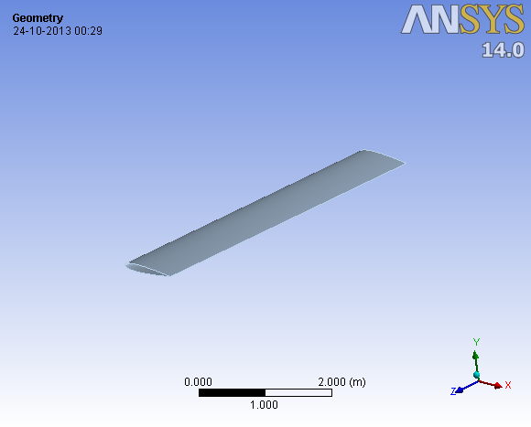

Fig.2 Geometry

After modelling the geometry, discretization is done. Mapped Face Meshing and Edge sizing features are used to create a mesh mapped into the rectangular domain. The element used in meshing the 2D airfoil domain is PLANE 182 and for the solid extruded part is SOLID 185.

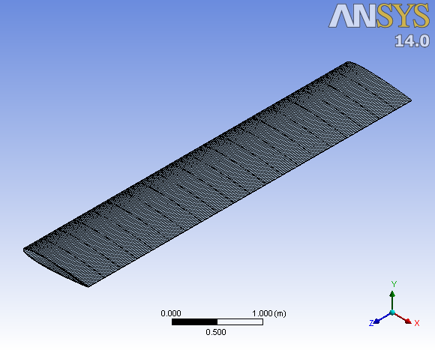

Fig.3 Meshing

The wing is assumed to be fixed at one end hence **Fixed Support** is used while defining the boundary conditions.

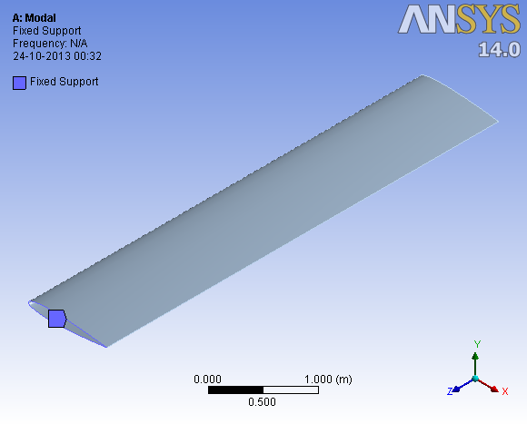

Fig.4 Fixed Support

**III. Results**

**a. Aluminum 6061-t6**

The properties of Aluminum 6061-T6 [3] are:

Elastic Modulus: 1e7 psi Density: 2700 kg/m3

The first 6 natural frequencies are shown in Table 1.

Table 1: Modal Frequencies of Aluminum 6061-T6

|  |  |  |  |
| --- | --- | --- | --- |
| Mode | Natural Frequency (Hz) | Maximum Deformation (m) | Deformation Type |
| 1. | 4.8318 | 0.120 | Bending |
| 2. | 25.321 | 0.118 | Bending |
| 3. | 32.168 | 0.119 | Bending |
| 4. | 38.081 | 0.135 | Twisting |
| 5. | 48.304 | 0.143 | Combined Bending and Twisting |
| 6. | 53.528 | 0.193 | Combined Bending and Twisting |

**b. Titanium 3.7165**

The properties of Titanium 3.7165 [4] are shown in Table 2:

Elastic Modulus: 1.5e7 psi Density: 4400 kg/m3

Table 2: Modal Frequencies of Titanium 3.7165

|  |  |  |  |
| --- | --- | --- | --- |
| Mode | Natural Frequency (Hz) | Maximum Deformation (m) | Deformation Type |
| 1 | 4.6357 | 0.0945 | Bending |
| 2. | 24.293 | 0.092 | Bending |
| 3. | 30.862 | 0.093 | Bending |
| 4. | 36.535 | 0.106 | Twisting |
| 5. | 46.343 | 0.112 | Combined Bending and Twisting |
| 6. | 51.355 | 0.151 | Combined Bending and Twisting |

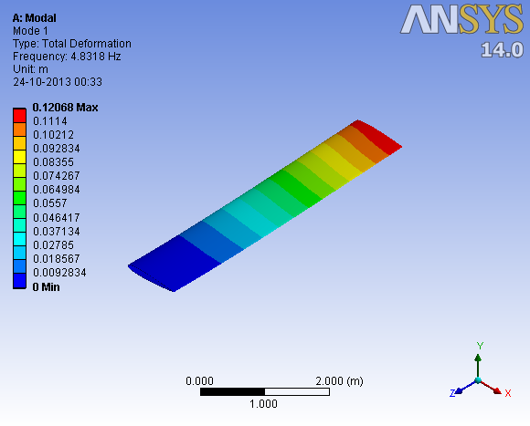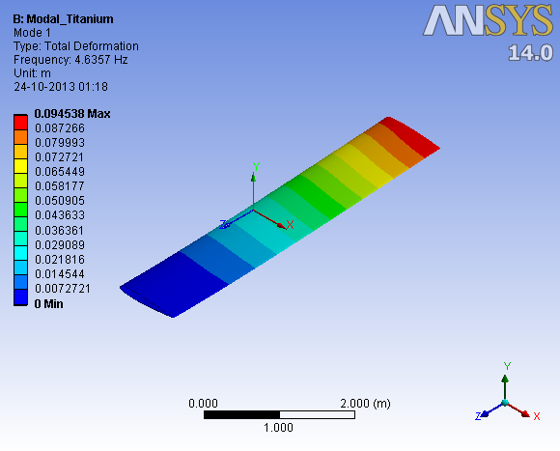

(a) (b)

Fig.5 Mode 1: (a): Aluminium 6061-T6 (b): Titanium 3.7165

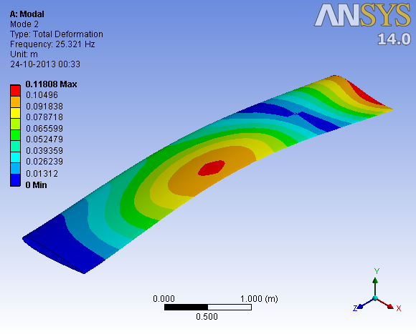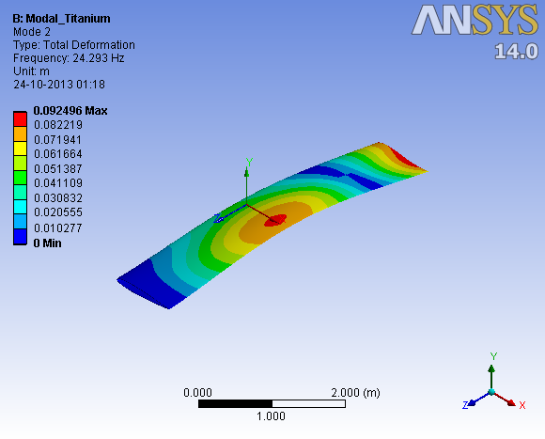

(a) (b)

Fig.6 Mode 2: Aluminium 6061-T6 (b): Titanium 3.7165

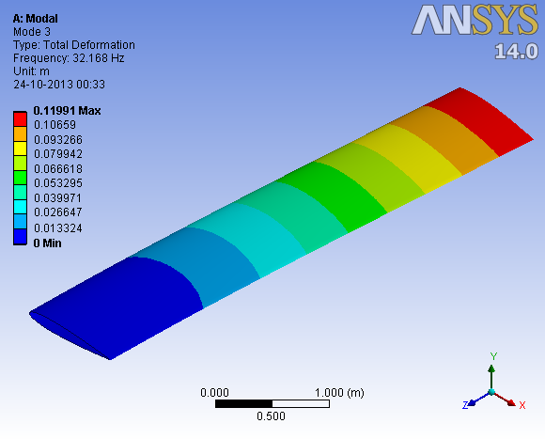 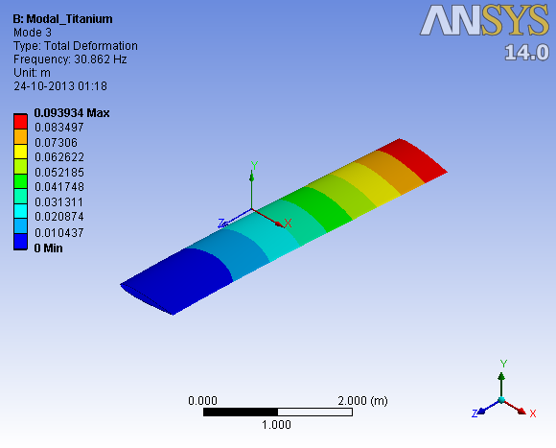

(a) (b)

Fig.7 Mode 3: Aluminium 6061-T6 (b): Titanium 3.7165

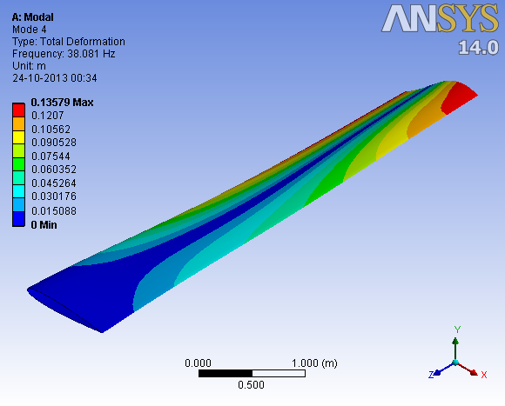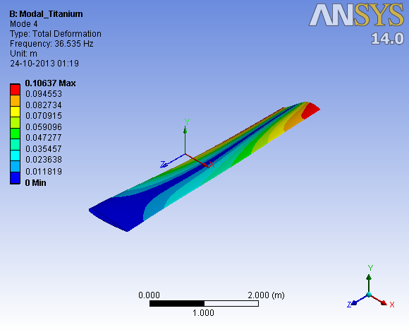

(a) (b)

Fig.8 Mode 4: Aluminium 6061-T6 (b): Titanium 3.7165

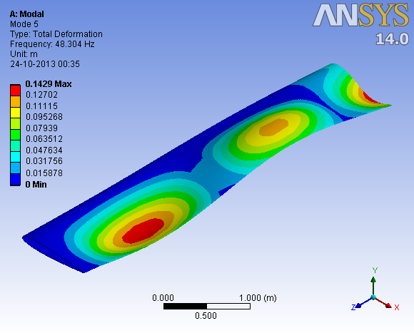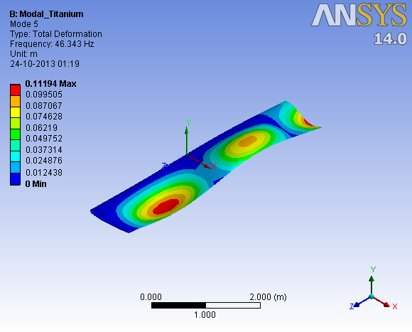

(a) (b)

Fig.9 Mode 5: Aluminium 6061-T6 (b): Titanium 3.7165

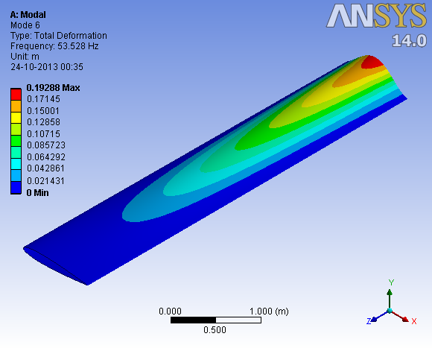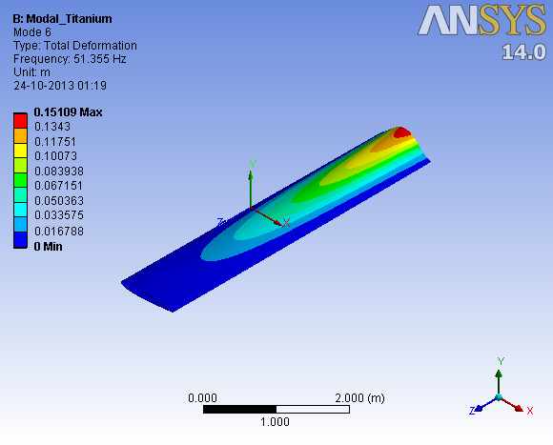

(a) (b)

Fig.10 Mode 6: Aluminium 6061-T6 (b): Titanium 3.7165

**Conclusion:**

It can be established from the modal frequencies that due to higher elastic moduli of Titanium 3.7165 compared to Aluminum 6061 T6 the amount of deflection is lower in Titanium 3.7165 than in Aluminum 6061-T6. However, the cost of Aluminum 6061 T-6 is less compared to Titanium 3.7165. In future studies, the use of composite materials will be evaluated which provide a better alternative.

**References:**

[1] MODAL ANALYSIS, **Patrick Guillaume**, *Department of Mechanical Engineering,Vrije Universiteit Brussel*

[2] Strain-Based Analysis for Geometrically Nonlinear Beams: A Modal Approach, Weihua Su and Carlos E. S. Cesnik, 53rd AIAA/ASME/ASCE/AHS/ASC Structures, Structural Dynamics and Materials Conference,2012

[3] <http://www.makeitfrom.com/material-data/?for=6061-T6-Aluminum>

[4] <http://www.makeitfrom.com/material-data/?for=Grade-5-6Al-4V-3.7165-R56400-Titanium>